

The Peace Cycle – Route Plan & Meeting Points
The Hague to Brussels 28th–29th March 09

Important Notes:
- CYLISTS MUST HAVE THEIR OWN BICYCLES, HELMETS, FRONT AND REAR LIGHTS, AND SLEEPING BAGS
- All cyclists are responsible for bringing their own bicycle, which should be well maintained and in good condition. They are also responsible for bringing spare parts and basic maintenance equipment
- The Peace Cycle will endeavour to find a support vehicle, or funding for a support vehicle (~£300) to escort cyclists. However, if this is not possible, cyclists will be responsible for carrying their own luggage for the duration of the journey
- The Peace Cycle does not guarantee that there will be bike mechanics or qualified first aid professionals on all parts of the ride
- Addresses and maps for meeting points are at the end of the document
- In the case of shared accommodation, it may be necessary for cyclists to bring sleeping bags

EMERGENCY CONTACT NUMBERS ON THE RIDE:
- Heidi (main event coordinator): +44(0)7813 165 139
- Irshad (cyclist coordinator): +44(0)7709 139 527
- Fizza (publicity coordinator): +44(0)7811 253 600
- Jerry (lead rider): +44(0)7900 013 832

Saturday 28th March

09:00 – 09:30 Meeting Point 1: Meet in front of The International Courts of Justice (ICJ), The Hague

10:00 Media photo opportunity & depart ICJ

10:00 – 11:45 Cycle from ICJ to Rotterdam train station (25km, ~1hr 45min)

11:45 – 12:00 Meeting Point 2: Meet in front of Rotterdam train station (drop off point for those who want to take the train)

12:00 – 13:30 Cycle from Rotterdam train station to Klaaswaal (24km, ~1hr 30min)

13:30 – 14:30 Lunch stop in Klaaswaal

14:30 – 16:45 Cycle from Klaaswaal to Roosendaal train station (34km, ~2hrs 15min)

16:45 – 17:00 Meeting Point 3: Meet in front of Roosendaal train station (drop off/pick up point for those who want to take or who have taken the train)

17:00 – 19:45 Cycle from Roosendaal train station to the Zeemanshuis hotel in Antwerp (38km, ~2hrs 30mins), an extra 4km to the Op Sinjoorke youth hostel

Notes:
- Please bring your own packed lunch for Saturday (advisably wholegrain pasta or other slow-release carbohydrates) and plenty of other energy snacks. Our lunch stop will be a picnic. Bring some extra to share.
- Cyclists who take the train to Antwerp can go directly to their accommodation on arrival – the train station is not a meeting point.
- The youth hostel (Op Sinjoorke) is closer to Antwerp Zuid (south) station; the hotel (Zeemanshuis) is closer to Antwerp Centraal
- For train times and prices see below, for maps see end of document
- Cyclists who cycle to Antwerp can go directly to their accommodation.
- Sunset is at 19:09 on 28 March 2009 in Holland. This means that it will definitely be getting dark for the final part of the cycling and anyone wishing to cycle this part MUST HAVE LIGHTS ON THEIR BIKE!
- To add to the challenge - Clocks are changing to summer-time on Saturday night/Sunday morning – so we will lose an hour of sleep!

Train times and prices on Saturday 28 March:
Remember to get a ticket for your bicycle

Rotterdam-Centraal to Roosendaal: http://www.ns.nl/cs/Satellite/travellers
Trains are direct and take about 40 minutes, full price €9.60
Dep Rotterdam Arr Roosendaal
12:33 - 13:12
12:55 - 13:32
13.33 - 14:12
13:55 - 14:32
Etc…

Roosendaal to Antwerp-Centraal: http://www.b-rail.be/int/E/
Trains are direct and take 26 minutes, full price €8.80
Dep Roosendaal Arr Antwerp
13:34 - 14:00
14:34 - 15:00
15:34 - 16:00
16:34 - 17:00
Etc…

Rotterdam-Centraal to Antwerp-Centraal: http://www.b-rail.be/int/E/
Trains are direct and take about 1 hour, full price €18.80
Dep Rotterdam Arr Antwerp
12:55 - 14:00
13:55 - 15:00
14:26 - 15:26
14:55 - 16:00
15:55 - 17:00
16:55 - 18:00

Antwerp-Centraal to Antwerp-Zuid: http://www.b-rail.be/int/E/
Trains are direct and take about 7 minutes, leaving Antwerp-Centraal at :34 past the hour every hour.

Antwerp train station to youth hostel:
Note that the Op Sinjoorke Youth Hostel is nearer to the south train station Antwerpen-Zuid. The International Zeemanshuis Hotel is nearer to Antwerp Centraal station. (It is only about 2.7km between stations.)

- Antwerpen-Centraal to Op-Sinjoorke Youth Hostel (Eric Sasselaan, 2020 Antwerp): 4.5km, ~20min cycle
- Antwerpen-Zuid (south) to Op-Sinjoorke Youth Hostel: 1.8km, ~10min cycle
- Antwerpen-Centraal to International Zeemanshuis (Falconrui 21, 2000 Antwerp): 1.7km, ~10min cycle
Maps for these journeys are given after the Meeting Point maps, at the end of the document.

Sunday 29th March

09:15 – 09:30 Meeting Point 4: Meet at Antwerp youth hostel (also meet our Belgian friends from Palestine-Palestina Via Velo)

10:00 – 15:00 Cycle from Antwerp youth hostel to Le Gare du Nord, Brussels, stopping for lunch on the way (45km, ~3hrs)

15:00 – 15:30 Meeting Point 5: Meet at Bruxelles-Nord station (Noordstation), Brussels

16:00 – 16:30 Meeting Point 6: Les Halles de Schaerbeek, Brussels (for reception and events all evening and sleeping there)

Notes:
- We will be meeting our friends from the Belgian group Palestine-Palestina Via-Velo. Their group was inspired and founded after The Peace Cycle travelled through Brussels in 2006, and have entirely similar aims to us.
- The cycling on this day will be slower and more relaxed, and more about integrating and meeting new people than about being fast!
- The group Palestine-Palestina Via-Velo along with others are hosting a reception and events for us from 16:00 into the evening at Les Halles de Schaerbeek for us. It will include a choral reception with AWSA (Arab Women’s Solidarity Association), speeches, poetry, stalls, food and drink, and hip-hop with the Gaza Team!

Donations to TPC
The Peace Cycle is a non-profit organisation that is run entirely by volunteers in their spare time. We are entirely dependent on donations. Please consider donating at least £20 to go towards our organisational costs.

UK Bank Details:
Account Name: The Peace Cycle Account No: 03567727 Sort code: 30-94-41

For International transfers:
IBAN: GB69 LOYD 309441 03567727 BIC: LOYDGB21084

Meeting Points

Meeting Point 1: 09:00 – 09:30 Saturday 28 March
The International Courts of Justice, Carnegieplein 2, 2517 KJ The Hague
MEET IN FRONT OF PEACE PALACE ON CARNEGIEPLEIN (ICJ IS INSIDE PALACE)

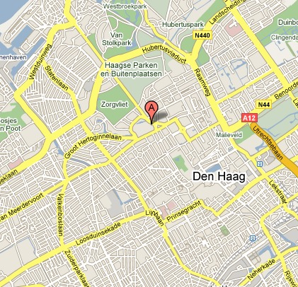

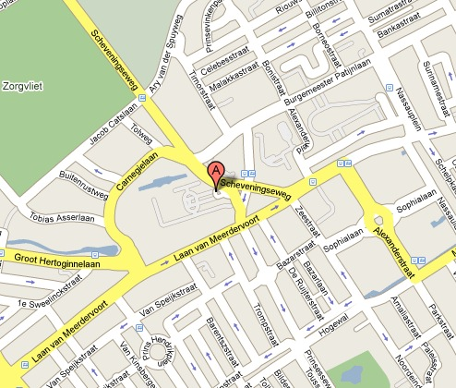

Meeting Point 2: 11:45 – 12:00 Saturday 28 March
Rotterdam Centraal train station, Stationssingel 10, 3013 Rotterdam
MEET IN FRONT OF MAIN ENTRANCE ON STATIONSSINGEL

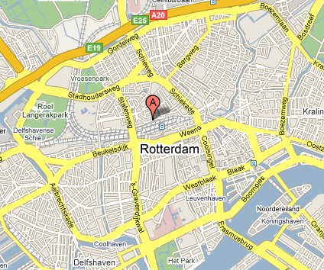

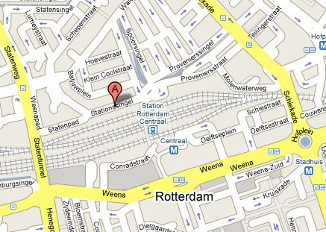

Meeting Point 3: 16:45 – 17:00 Saturday 28 March
Station Roosendaal (train station), Stationsplein 1, 4702 Roosendaal
MEET IN FRONT OF MAIN ENTRANCE ON STATIONSPLEIN

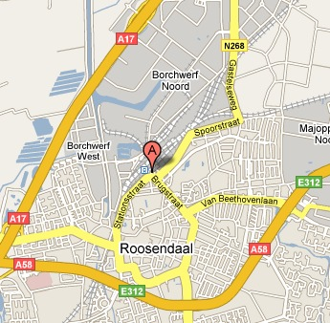

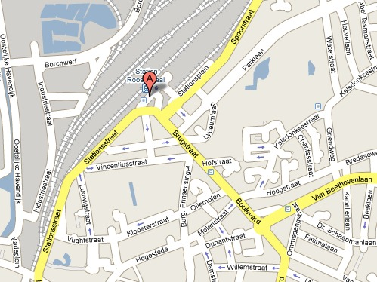

Meeting Point 4: 09:15 – 09:30 Sunday 29 March
Op-Sinjoorke Youth Hostel, Eric Sasselaan 2, 2020 Antwerp
MEET IN YOUTH HOSTEL RECEPTION OR MEETING AREA

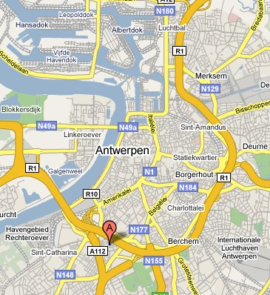

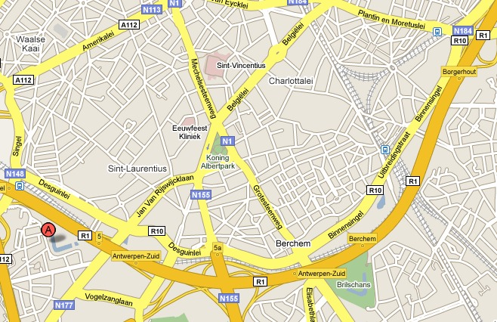

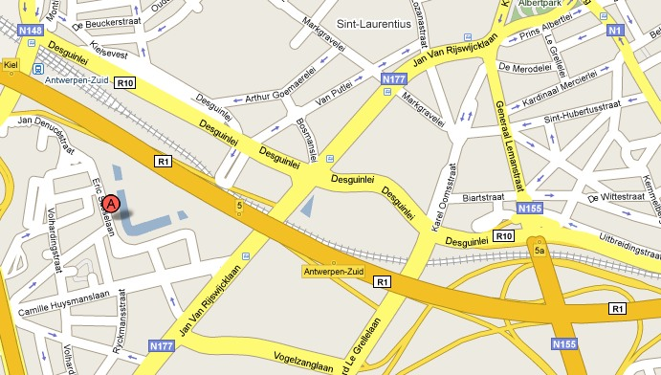

Meeting Point 5: 15:00 – 15:30 Sunday 29 March
Bruxelles-Nord station, Simón Bolívarlaan, 1030 Schaerbeek, Brussels
MEET ON THE CORNER OF BOULEVARD SIMÓN BOLÍVARLAAN AND RUE DE PROGRÈS

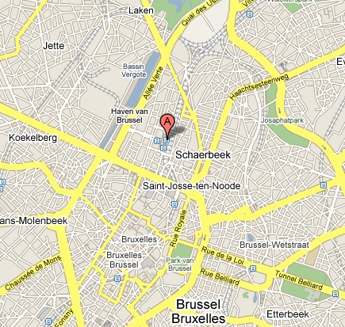
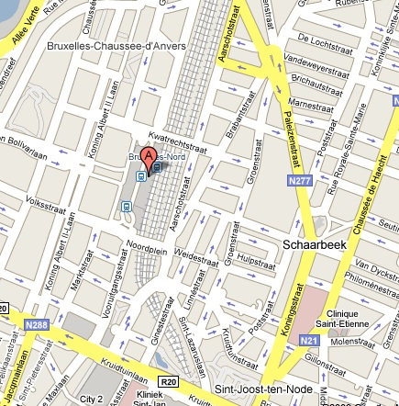

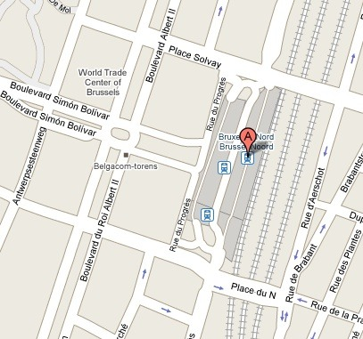
Meeting Point 6: 16:00 – 16:30 Sunday 29 March
Les Halles de Schaerbeek, Rue Royale Ste Marie 22b, 1030 Schaerbeek, Brussels

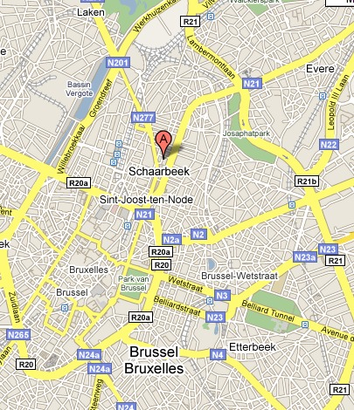

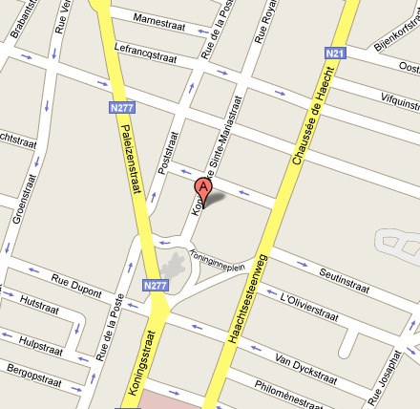
Antwerp train station to Zeemanshuis Hotel

Antwerpen-Centraal to International Zeemanshuis Hotel (Falconrui 21, 2000 Antwerp): 1.7km, ~10min cycle

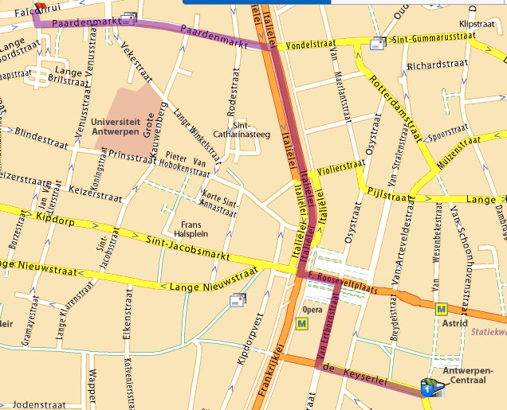

Antwerp train stations to Op Sinjoorke Youth Hostel

Antwerpen-Centraal to Op-Sinjoorke Youth Hostel (Eric Sasselaan, 2020 Antwerp): 4.5km, ~20min cycle

Antwerp Centraal train station to Youth Hostel: ZOOM OUT
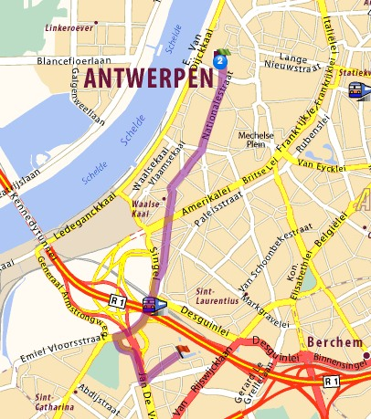

Antwerp-Centraal train station to Youth Hostel 1:
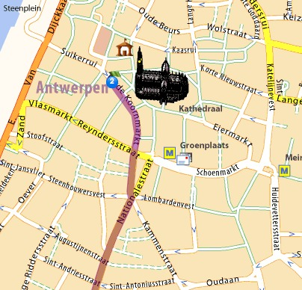
Antwerp-Centraal train station to Youth Hostel 2: Antwerp-Centraal train station to Youth Hostel 3:
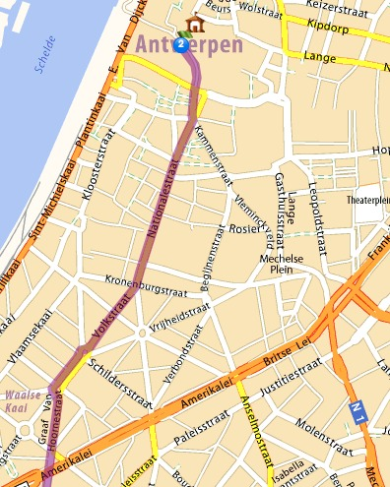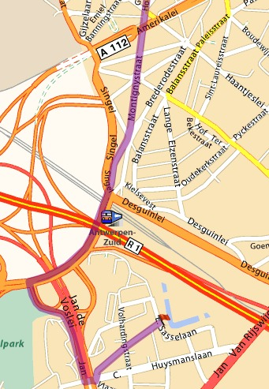

Antwerp-Centraal train station to Youth Hostel 4:
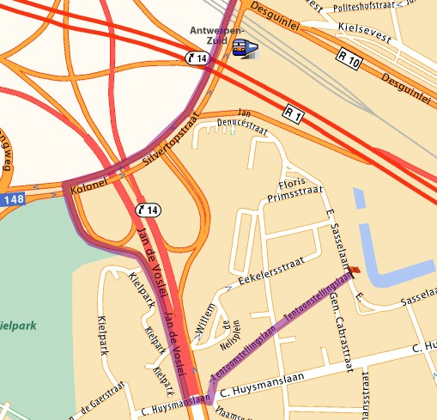

Antwerpen-Zuid (south) to Op-Sinjoorke Youth Hostel: 1.8km, ~10min cycle

Antwerp-Zuid to Antwerp Youth Hostel:
